Experiment 5A

2018BTECS00019

Picture of web page:

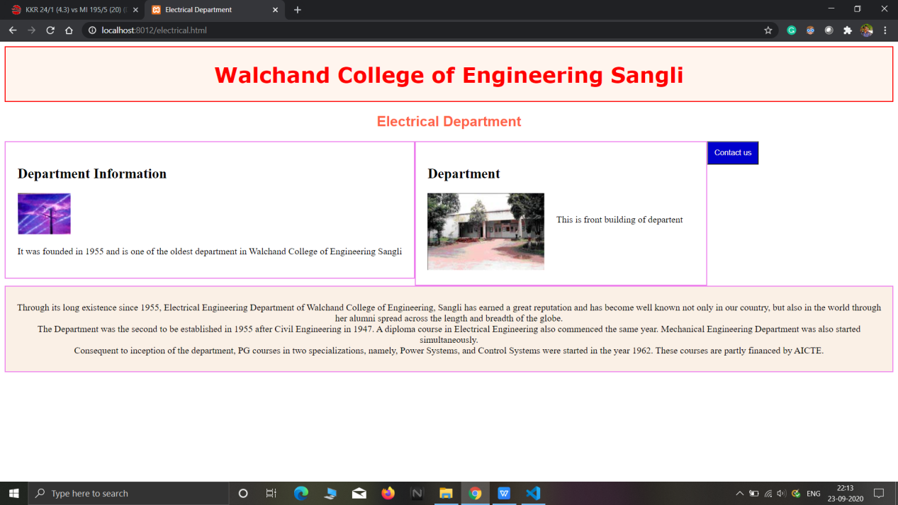

Accessing web page from mobile:

